**What is Shortest Job First Scheduling?**

**Shortest Job First (SJF)** is an algorithm in which the process having the smallest execution time is chosen for the next execution. This scheduling method can be preemptive or non-preemptive. It significantly reduces the average waiting time for other processes awaiting execution. The full form of SJF is Shortest Job First.

**There are basically two types of SJF methods:**

* Non-Preemptive SJF
* Preemptive SJF

**Characteristics of SJF Scheduling**

* It is associated with each job as a unit of time to complete.
* This algorithm method is helpful for batch-type processing, where waiting for jobs to complete is not critical.
* It can improve process throughput by making sure that shorter jobs are executed first, hence possibly have a short turnaround time.
* It improves job output by offering shorter jobs, which should be executed first, which mostly have a shorter turnaround time.

**Non-Preemptive SJF**

In non-preemptive scheduling, once the CPU cycle is allocated to process, the process holds it till it reaches a waiting state or terminated.

Consider the following five processes each having its own unique burst time and arrival time.

| **Process Queue** | **Burst time** | **Arrival time** |
| --- | --- | --- |
| P1 | 6 | 2 |
| P2 | 2 | 5 |
| P3 | 8 | 1 |
| P4 | 3 | 0 |
| P5 | 4 | 4 |

**Step 0)**At time=0, P4 arrives and starts execution.

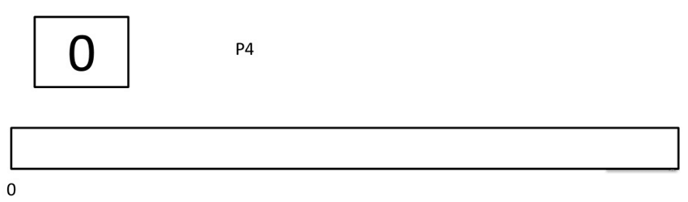

**Step 1)**At time= 1, Process P3 arrives. But, P4 still needs 2 execution units to complete. It will continue execution.

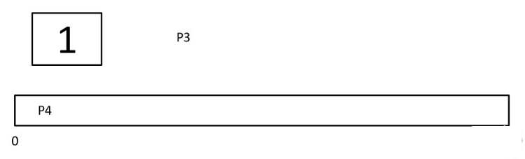

**Step 2)**At time =2, process P1 arrives and is added to the waiting queue. P4 will continue execution.

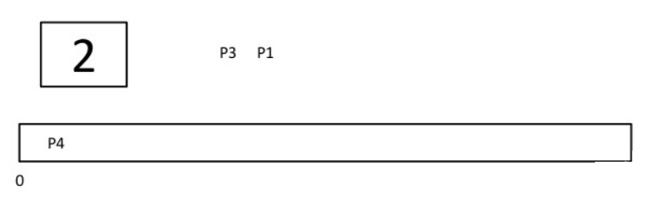

**Step 3)**At time = 3, process P4 will finish its execution. The burst time of P3 and P1 is compared. Process P1 is executed because its burst time is less compared to P3.

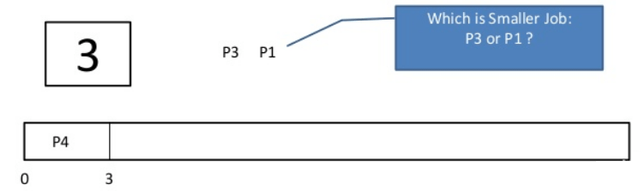

**Step 4)**At time = 4, process P5 arrives and is added to the waiting queue. P1 will continue execution.

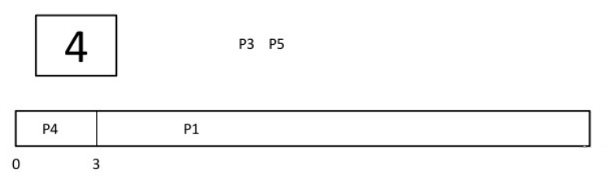

**Step 5)** At time = 5, process P2 arrives and is added to the waiting queue. P1 will continue execution.

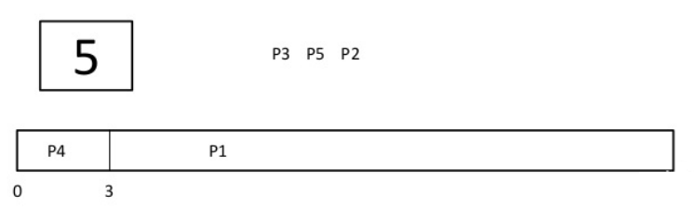

**Step 6)**At time = 9, process P1 will finish its execution. The burst time of P3, P5, and P2 is compared. Process P2 is executed because its burst time is the lowest.

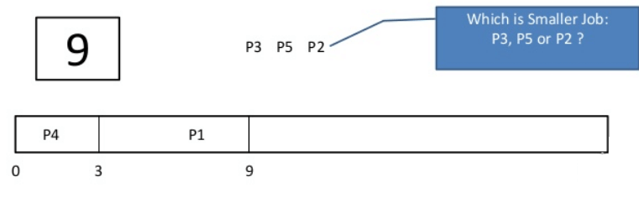

**Step 7)**At time=10, P2 is executing and P3 and P5 are in the waiting queue.

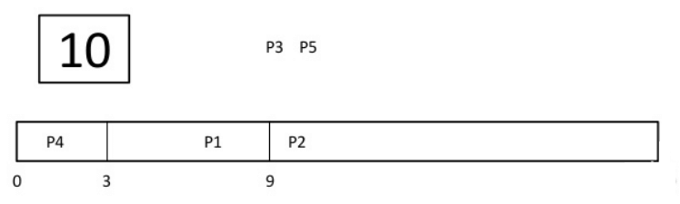

**Step 8)**At time = 11, process P2 will finish its execution. The burst time of P3 and P5 is compared. Process P5 is executed because its burst time is lower.

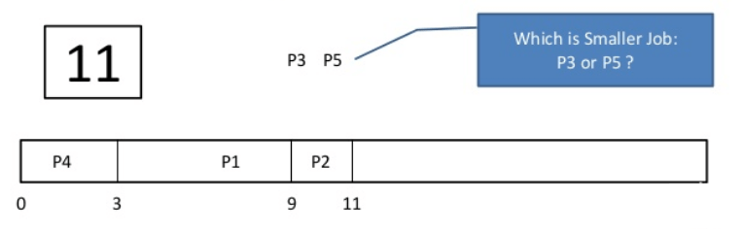

**Step 9)**At time = 15, process P5 will finish its execution.

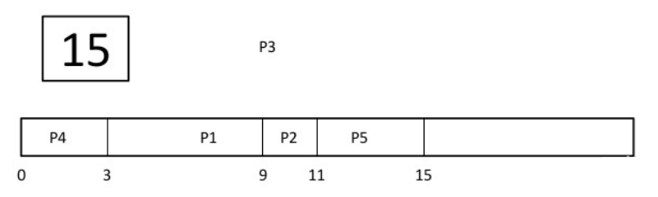

**Step 10)**At time = 23, process P3 will finish its execution.

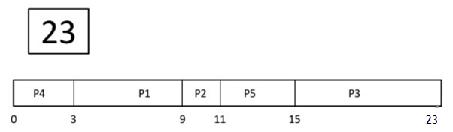

**Step 11)**Let’s calculate the average waiting time for above example.

Wait time

P4= 0-0=0

P1= 3-2=1

P2= 9-5=4

P5= 11-4=7

P3= 15-1=14

Average Waiting Time= 0+1+4+7+14/5 = 26/5 = 5.2

**Preemptive SJF**

In Preemptive SJF Scheduling, jobs are put into the ready queue as they come. A process with shortest burst time begins execution. If a process with even a shorter burst time arrives, the current process is removed or preempted from execution, and the shorter job is allocated CPU cycle.

Consider the following five process:

| **Process Queue** | **Burst time** | **Arrival time** |
| --- | --- | --- |
| P1 | 6 | 2 |
| P2 | 2 | 5 |
| P3 | 8 | 1 |
| P4 | 3 | 0 |
| P5 | 4 | 4 |

**Step 0)**At time=0, P4 arrives and starts execution.

| **Process Queue** | **Burst time** | **Arrival time** |
| --- | --- | --- |
| P1 | 6 | 2 |
| P2 | 2 | 5 |
| P3 | 8 | 1 |
| P4 | 3 | 0 |
| P5 | 4 | 4 |
|  |  |  |

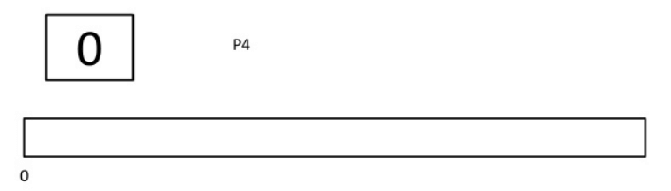

**Step 1)**At time= 1, Process P3 arrives. But, P4 has a shorter burst time. It will continue execution.

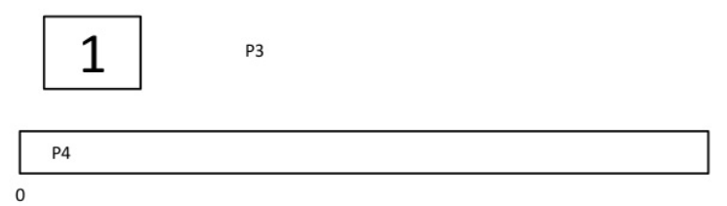

**Step 2)**At time = 2, process P1 arrives with burst time = 6. The burst time is more than that of P4. Hence, P4 will continue execution.

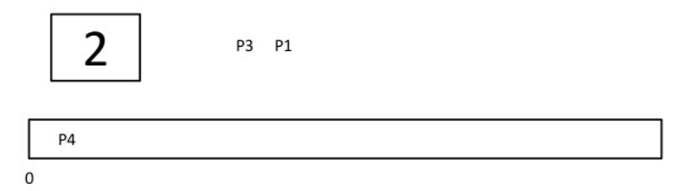

**Step 3)**At time = 3, process P4 will finish its execution. The burst time of P3 and P1 is compared. Process P1 is executed because its burst time is lower.

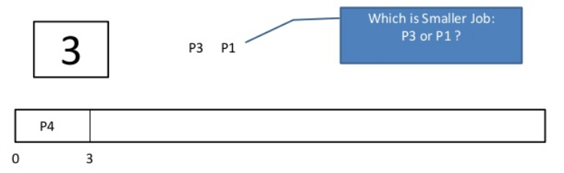

**Step 4)**At time = 4, process P5 will arrive. The burst time of P3, P5, and P1 is compared. Process P5 is executed because its burst time is lowest. Process P1 is preempted.

| **Process Queue** | **Burst time** | **Arrival time** |
| --- | --- | --- |
| P1 | 5 out of 6 is remaining | 2 |
| P2 | 2 | 5 |
| P3 | 8 | 1 |
| P4 | 3 | 0 |
| P5 | 4 | 4 |

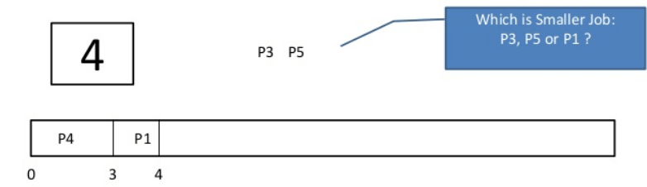

**Step 5)**At time = 5, process P2 will arrive. The burst time of P1, P2, P3, and P5 is compared. Process P2 is executed because its burst time is least. Process P5 is preempted.

| **Process Queue** | **Burst time** | **Arrival time** |
| --- | --- | --- |
| P1 | 5 out of 6 is remaining | 2 |
| P2 | 2 | 5 |
| P3 | 8 | 1 |
| P4 | 3 | 0 |
| P5 | 3 out of 4 is remaining | 4 |
|  |  |  |

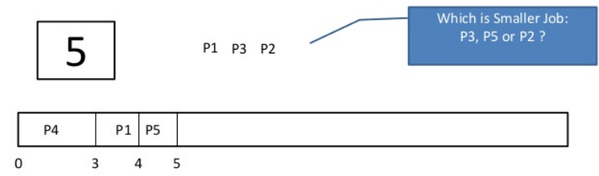

**Step 6)**At time =6, P2 is executing.

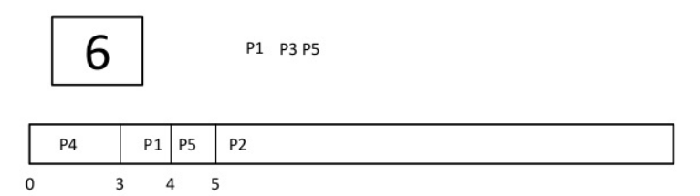

**Step 7)**At time =7, P2 finishes its execution. The burst time of P1, P3, and P5 is compared. Process P5 is executed because its burst time is lesser.

| **Process Queue** | **Burst time** | **Arrival time** |
| --- | --- | --- |
| P1 | 5 out of 6 is remaining | 2 |
| P2 | 2 | 5 |
| P3 | 8 | 1 |
| P4 | 3 | 0 |
| P5 | 3 out of 4 is remaining | 4 |
|  |  |  |

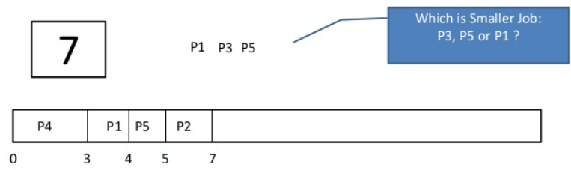

**Step 8)** At time =10, P5 will finish its execution. The burst time of P1 and P3 is compared. Process P1 is executed because its burst time is less.

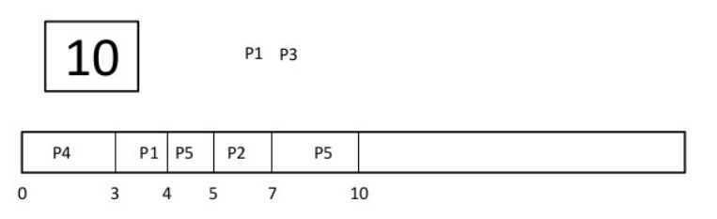

**Step 9)**At time =15, P1 finishes its execution. P3 is the only process left. It will start execution.

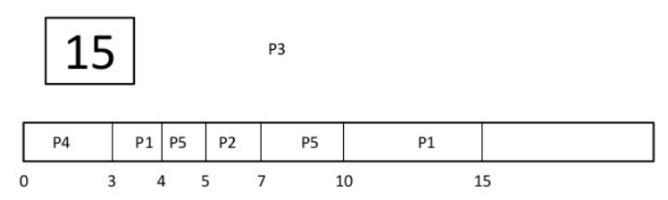

**Step 10)**At time =23, P3 finishes its execution.

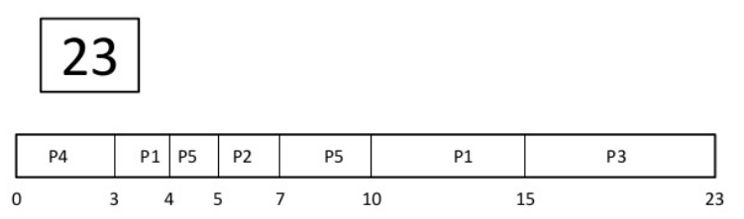

**Step 11)**Let’s calculate the average waiting time for above example.

Wait time

P4= 0-0=0

P1= (3-2) + 6 =7

P2= 5-5 = 0

P5= 4-4+2 =2

P3= 15-1 = 14

Average Waiting Time = 0+7+0+2+14/5 = 23/5 =4.6

**Advantages of SJF**

Here are the benefits/pros of using SJF method:

* SJF is frequently used for long term scheduling.
* It reduces the average waiting time over FIFO (First in First Out) algorithm.
* SJF method gives the lowest average waiting time for a specific set of processes.
* It is appropriate for the jobs running in batch, where run times are known in advance.
* For the batch system of long-term scheduling, a burst time estimate can be obtained from the job description.
* For Short-Term Scheduling, we need to predict the value of the next burst time.
* Probably optimal with regard to average turnaround time.

**Disadvantages/Cons of SJF**

Here are some drawbacks/cons of SJF algorithm:

* Job completion time must be known earlier, but it is hard to predict.
* It is often used in a batch system for long term scheduling.
* SJF can’t be implemented for CPU scheduling for the short term. It is because there is no specific method to predict the length of the upcoming CPU burst.
* This algorithm may cause very long turnaround times or starvation.
* Requires knowledge of how long a process or job will run.
* It leads to the starvation that does not reduce average turnaround time.
* It is hard to know the length of the upcoming CPU request.
* Elapsed time should be recorded, that results in more overhead on the processor.

**Summary**

* SJF is an algorithm in which the process having the smallest execution time is chosen for the next execution.
* SJF Scheduling is associated with each job as a unit of time to complete.
* This algorithm method is helpful for batch-type processing, where waiting for jobs to complete is not critical.
* There are basically two types of SJF methods 1) Non-Preemptive SJF and 2) Preemptive SJF.
* In non-preemptive scheduling, once the CPU cycle is allocated to process, the process holds it till it reaches a waiting state or terminated.
* In Preemptive SJF Scheduling, jobs are put into the ready queue as they come.
* Although a process with short burst time begins, the current process is removed or preempted from execution, and the job which is shorter is executed 1st.
* SJF is frequently used for long term scheduling.
* It reduces the average waiting time over FIFO (First in First Out) algorithm.
* In SJF scheduling, Job completion time must be known earlier, but it is hard to predict.
* SJF can’t be implemented for CPU scheduling for the short term. It is because there is no specific method to predict the length of the upcoming CPU burst.